**C ppl ok cool. It***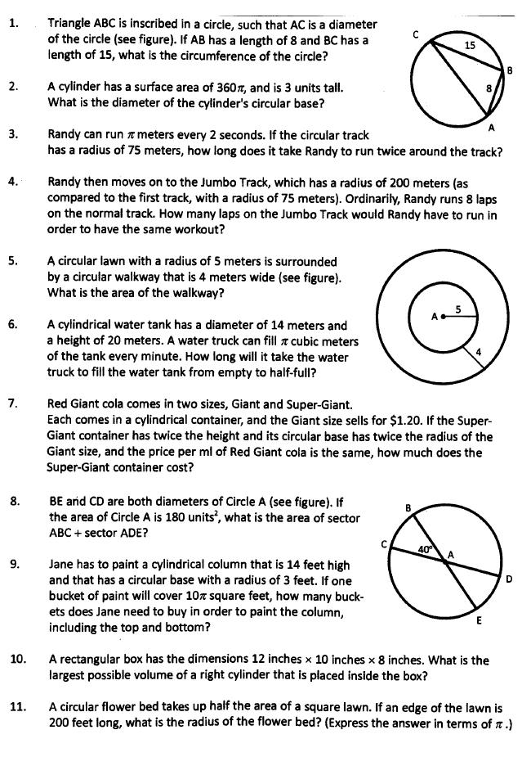*

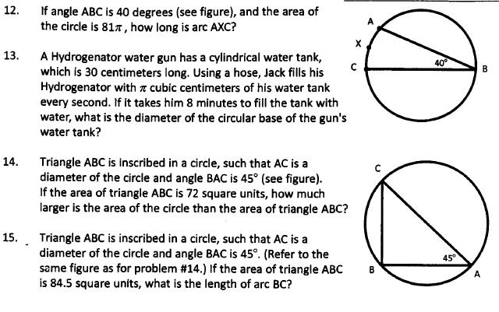

1. 17 $π$
2. 24
3. 10 minutes
4. 3 laps
5. 56 $π$
6. 8 hours and 10 minutes
7. 9.6
8. 40
9. 11
10. 200 $π$
$\sqrt{\frac{20000}{π}}$

11. 4 $π$
12. 8
13. 72 $π-72$

$\frac{13\sqrt{2}π}{4}$

**Lines**

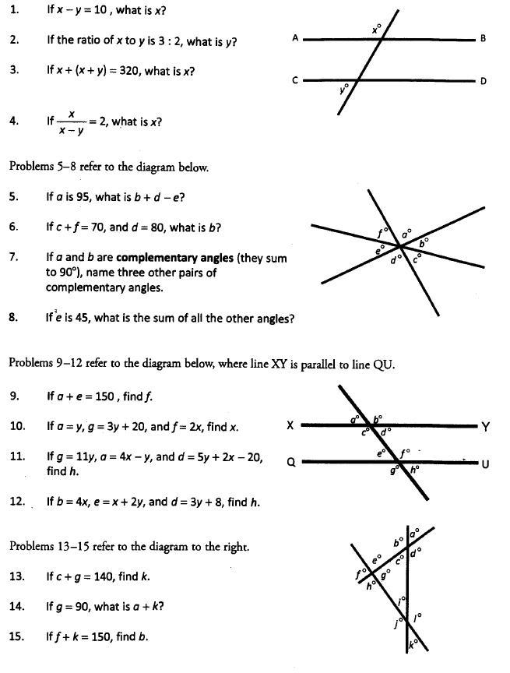

1. 95
2. 72
3. 140
4. 120
5. 95
6. 65
7. b&d, a&e, d&e
8. 315
9. 105
10. 70
11. 70
12. 68
13. 40
14. 90
15. 150

**Coordinate Geometry**

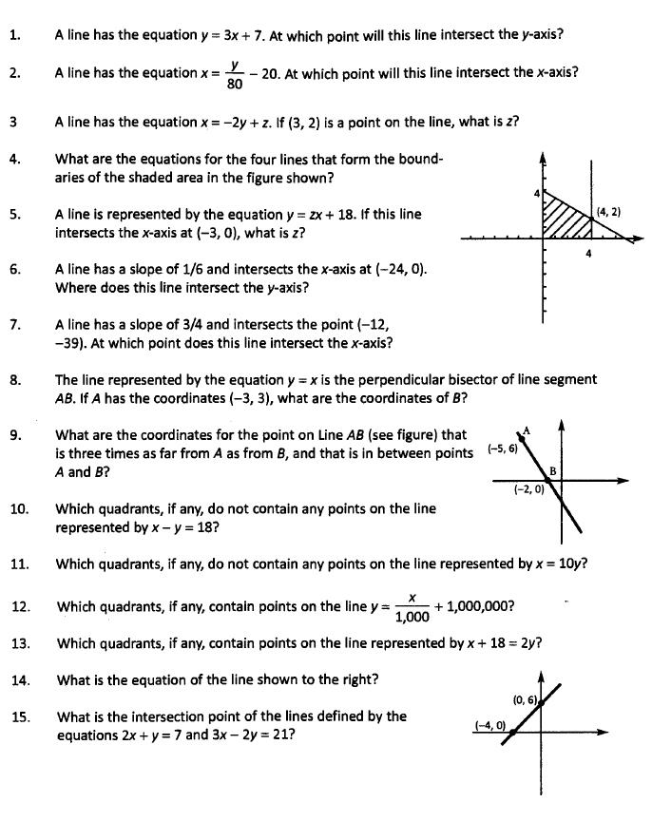

1. (0,7)
2. (-20,0)
3. 7
4. x=0, x=4, y=0 and y= $-\frac{1}{2}x+4$
5. 6
6. (0,4)
7. (40,0)
8. (3,-3)
9. ($-2.75, 1.5$)
10. II
11. II & IV
12. I, II & III
13. I, II & III
$y=\frac{3}{2}x+6$

14. (5, -3)

**Some tricky questions**

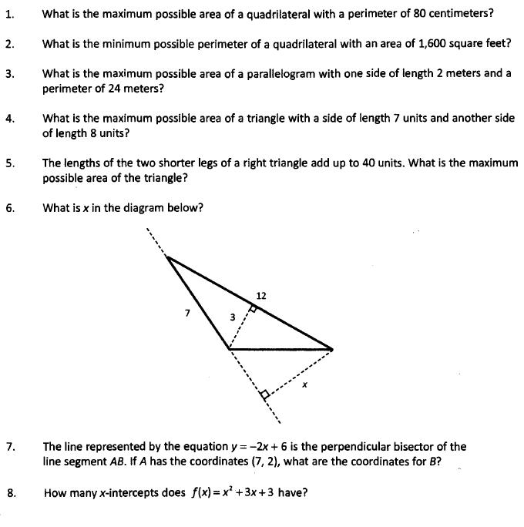

1. 400
2. 160
3. Less than 20
4. 28
5. 200
$\frac{36}{7}$

6. (-1, -2)
7. none

**Miscellaneous Questions**

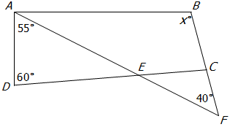

1. In the figure above if AB || CD, what is the value of x? 75

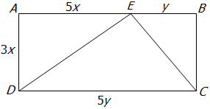

1. If AD = 3x, AE = 5x, EB = y and DC = 5y, what is the ratio of the area of triangle DEC to the area of rectangle ABCD? 1:2

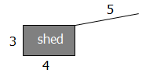

1. A cow is tethered to the corner of a shed. If the length of the rope is 5, and the shed has length 4 and width 3, what is the maximum area that is accessible to the cow? (The cow cannot enter the shed). 20 $π$

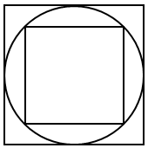

1. In the figure above, if the area of the outer square is http://math.edim.co/4402fb595cf97f664445cd2f3651440d.png, then the area of the inner square is 2x²
2. If the ratio of the volume of cube A to the volume of cube B is 1 to 8, what is the ratio of the surface area of cube A to the surface area of cube B? 1:4

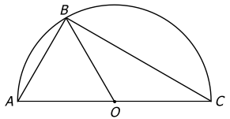

1. In the figure above, O is the center of the semicircle. If angle BCO is 30 and BC = http://math.edim.co/849e69e3e70e1edfa9b0764a4fe962a5.png, what is the area of triangle ABO? 9 $\sqrt{3}$
2. In the xy-coordinate system, a circle with radius http://math.edim.co/f10ac6fceee41bb786d24ee337f02bab.pngand center (2,1) intersects the x-axis at (k ,0). One possible value of k is 2+ $\sqrt{29} \& \sqrt{29}-2$

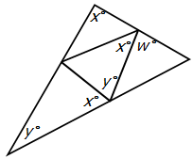

1. For the figure above, what is the value of w in terms of x and y? $w=2\left(x+y\right)-180$

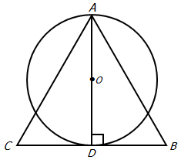

1. For the figure above, if the circle with center O has area 9π, what is area of equilateral triangle ABC? (Give your answer to the nearest hundredth) 20.80 or $\frac{36}{\sqrt{3}}$

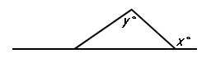

1. Column A: x   
   Column B: y

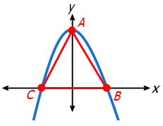

1. The figure shows the graph of the equation $y =k–x^{2}$, where k is a constant. If the area of triangle ABC is 1/8, what is the value of k? k = $\frac{1}{4}$